|  |  |  |
| --- | --- | --- |
|  | **Rochester Institute of Technology**  **Golisano College of Computing and Information Sciences**  **School of Interactive Games and Media**  **2145 Golisano Hall – (585) 475-7680** |  |

**Data Structures & Algorithms for Games & Simulation II**

**IGME 309**

**E05: LERP**

This exercise follows lecture 14B - LERP

It is meant to help you practice the use of glm library’s LERP method.

There is starter code for this project, you will find it under our class repository with the name E05_LERP but you want to use your own framework you are welcome to translate the starting code to it.

Once you open the solution you will be presented with the following scene:

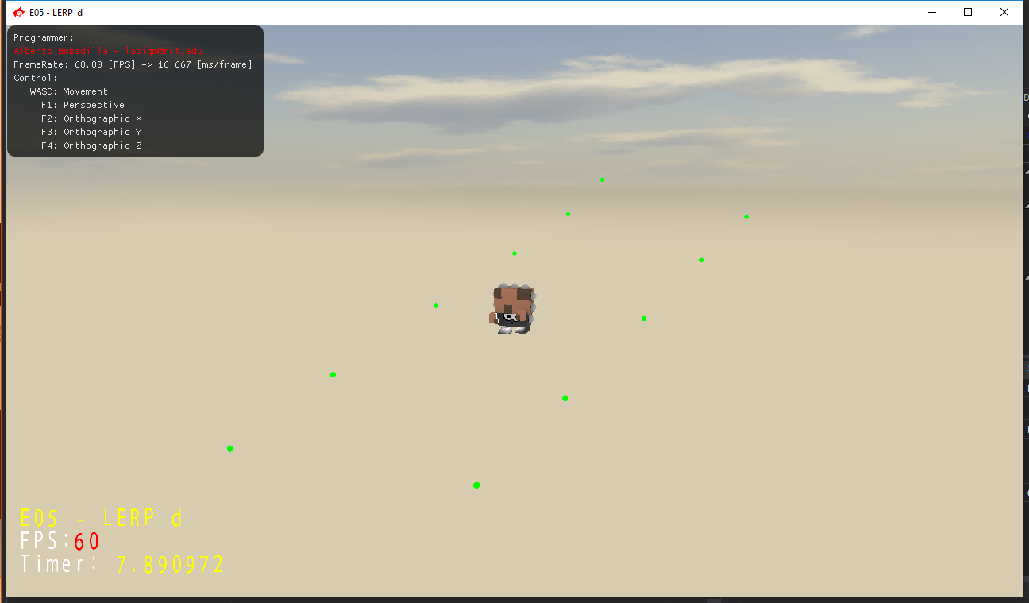

The character should be at the origin of the world and being animated, if you are using your own solution and/or do not want to work with this animated character do not worry about it, you can use any basic primitive. You will be graded based on the movement not what you use for it.

The starter code is providing an std::vector of vector3s those are the stops that the character has to go through:

vector3(-4.0f,-2.0f, 5.0f);

vector3(1.0f,-2.0f, 5.0f);

vector3(-3.0f,-1.0f, 3.0f);

vector3(2.0f,-1.0f, 3.0f);

vector3(-2.0f, 0.0f, 0.0f);

vector3(3.0f, 0.0f, 0.0f);

vector3(-1.0f, 1.0f,-3.0f);

vector3(4.0f, 1.0f,-3.0f);

vector3(0.0f, 2.0f,-5.0f);

vector3(5.0f, 2.0f,-5.0f);

vector3(1.0f, 3.0f,-5.0f);

Feel free to add more stops if you want.

There is also a time counter provided you may use it or create your own.

The system will draw the character on the position specified by the positional vector, so the exercise is reduced to just provide that location.

There is also an example demo in the repository under the _Binary folder.

Notes:

As usual, your submission is only a zipped version of the project NOT the whole solution, it should be less than 50 kb total, (unless you are using your own models/textures or your own framework solution). Push your solution to your repository with the comment “**E04 Deliverable**” then zip the project and upload it to the dropbox, in the comments section you need to specify the address of your repository. Example:

